SWEEPSTAKE – THE END (of part 1, at least!)
So we come to the end of this sweepstake. We left it with the top of the table looking like this with two matches to go:
1 | 202 | Pal Jacobsen
2 | 200 | Max Auvenne 2
3 | 199 | Birgitta Malmport
4 | 197 | Ines Maillart
5 | 196 | Silvio Mascagna
6 | 195 | Martin Schwabe
6 | 195 | Alan Bugeja
6 | 195 | Lucas Weinzierl
6 | 195 | Tom Shields

By my reckoning any of the top three could still win.
The final two games of the first stage of the World Cup saw Austria play Algeria and Argentina play Jordan.
At EURO2024 Austria played the most entertaining game of the tournament when they lost 1-2 to Turkey. Their match v Algeria turned out to be the most entertaining of this World Cup so far – and a far cry from the “Disgrace of Gijon” in 1982 when Austria eliminated Algeria from that World Cup by fixing a game with West Germany.
196 sweepstakers predicted a draw for this game – though alas not Pal Jacobsen. However, the final result of 3-3 (with two goals in added time!) was called correctly by only two of you: great work by Kemal Önel and Miguel Martins Valente!
After adding the result of the Austria match the table looked like this:
1 | 206 | Max Auvenne 2
2 | 205 | Birgitta Malmport
3 | 203 | Ines Maillart
4 | 202 | Pal Jacobsen
4 | 202 | Silvio Mascagna
6 | 201 | Tom Shields
7 | 199 | Hugues van Honacker
8 | 198 | Simão Ferreira
8 | 198 | Jean-Baptiste Roche 2
8 | 198 | Morten Bangsgaard 2

The second match saw Argentina easily beat a weak Jordan 3-1. 98% of sweepstakers forecast an Argentinian victory, with 37 tipping the correct score.
For the two games Joao Ferreira was the only sweepstaker to get a perfect 10! Excellent! Meanwhile, I think you can guess who got ‘nul’ points! Yannis Kousis was one of five people to score 0 from the final two matches, the others being Simone Nielsen, Pete Cain, Ilyas Önel and Rafal Stanecki.
And now we need to add in the tie-breaker! Remember that?! You will recall that you were all asked to predict the first team to get a red card. And that team was South Africa, followed by Mexico and Paraguay. So, the 43 sweepstakers that predicted SA get an extra 0.5 points, the 21 that said Mexico get an extra 0.3 points and the 65 who said Paraguay get an extra 0.1 point.
So, how does this sweepstake end? The bottom of the table looks like this:

493 | 123 | Rafal Stanecki
494 | 115 | Maximilian de Lannoy
494 | 115 | Lottie Bourne
496 | 99.5 | Ewa Galeza
497 | 95 | Robin Bourne
498 | 73 | Yannis Kousis

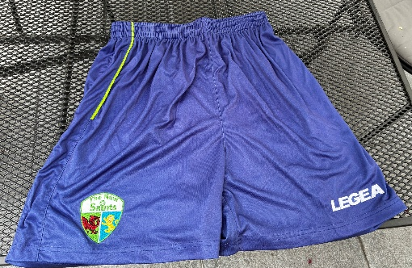
It is great to see two members of the Draper family respecting the traditions of punditry laid down by David Draper, but even with their genetic advantages they could not get close to the abilities of Yannis Kousis to come in last place by a long way!
And we have a most appropriate prize for Yannis as the David Draper Memorial Trophy for his pants performance: thanks to a German source (don’t ask questions) he shall receive a pair of shorts of the Welsh football champions TNS (as described in the ramblings article about strange names of teams )– I cannot think of a more futile football-themed prize!
 | PTS |  | PRIZE MONEY
1 | 207 | Max Auvenne 2 | €1,000
2 | 206 | Pal Jacobsen | €500
3 | 205 | Birgitta Malmport | €300
4 | 203 | Ines Maillart | €175
4 | 203 | Silvio Mascagna | €175
6 | 202.1 | Tom Shields | €100
7 | 200 | Hugues van Honacker | €75
8 | 199.5 | Alan Bugeja | €60
9 | 198.5 | Lucas Weinzierl | €50
9 | 198.5 | Martin Schwabe | €50

But let us turn to the winners.
After a very close race the top of the table finished like this:

Congratulations to all who finished in the top ten and get prize money – the money will be e-mailed to you within 90 working days……
The full sweepstake table showing everyone’s position is attached and on the website
Home | Robs Sweepstake
And for those who want more I will be e-mailing you soon with details of a new sweepstake for the latter stages of the World Cup.

